EVENT NAME: Native trees of B.C. Walk—Discovering Vancouver’s native trees. (OR you could use the working title under “Event description”).

EVENT DATE: Saturday 17 November 2012. Sunday 18 November in case of rain.

EVENT TIME: 10 am - noon

LOCATION: Meet along North Lagoon Drive at Tatlow Walk in Stanley Park. There is plenty of parking along North Lagoon Drive.

Map here:

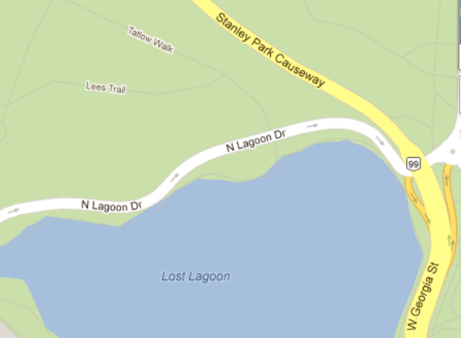
Parking
Meet here
Second Beach ½ km south of Lost Lagoon

EVENT DESCRIPTION: NATURALIST-LED WALK IN STANLEY PARK: LEARN YOUR TREES - THE NATIVES and THE ALIENS—a Story of a Forest.

Learn about native trees in British Columbia on this lively walk through the forest in Stanley Park.
Outdoor walk and talk on natural history of the forest by Kent Brothers who will take up to 15 people on a walk through Stanley Park. You will also learn about some of the mammals, birds, amphibians, and invertebrates whose home is Stanley Park.

If you have a hand lens or magnifying glass, bring it, for you will then be able to see cone structure or look sat small invertebrates. Participants should be prepared for possible cold and rainy weather with enough warm and waterproof clothes, as we will be doing quite a bit of standing around.

(TYPE OF EVENT AND A COUPLE SENTENCES SUMMARIZING ITS PURPOSE)

EVENT FEE: Free (Members/Non-members)

EVENTS PERKS: Guest speaker - trail guide (meal/snacks/drink, swag/prizes, guest speaker, none)

WILL THERE BE A SPEAKER? Yes—Kent Brothers (yes/no)

IF SO, PLEASE PROVIDE THEIR BIO/PHOTO
Dr. Kent Brothers, though a mathematical analyst by profession is an ecologist by avocation, and has studied biodiversity & ecology of the Pacific Northwest for the past 20 years. He is a past-president of the Vancouver Mycological Society, collaborates with the Department of Botany and the Herbarium at UBC, is a member of the advisory board for E-Flora BC, the online atlas of plants of BC, and is a member of the Pacific Northwest Key Council, an organization that develops identification keys to fungi. He regularly leads nature walks in the lower mainland.

RSVP: on Eventsbot (you may use the email pbaird11@gmail.com)

EVENT ORGANIZERS (IE, WICH LOGOS SHOULD GO ON THE POSTER?) SCWIST logo (do you have the logo?) (provide high resolution logos)

MEANS OF PROMOTION: ONLINE PDF 8.5X11 POSTER, e-bulletin, on the list serves of SCWIST'S sister organizations (ONLINE PDF 8.5X11 POSTER, PRINTABLE LARGE POSTER (SPECIFY SIZE), OTHER PRINT MEDIA)
DO WE WANT TO HAVE PRINTED COPIES TO PUT UP IN COMMUNITY CENTRES?

